High-Level Design (HLD)
Introduction
The High-Level Design (HLD) explains the overall structure and working of the Room Availability System. The system is designed to help users check room availability, make bookings, and manage room information easily. It provides communication between users, frontend interface, backend server, and database.
The main purpose of this system is to automate room management and reduce manual work in hotels, hostels, or guest houses.
System Architecture (Conceptual View)
The system architecture shows how different components interact with each other. Users access the system through the frontend interface. The frontend sends requests to the backend server, which processes data and communicates with the database.
- User Interface (Frontend)
- Backend Server
- Database
- Admin Panel
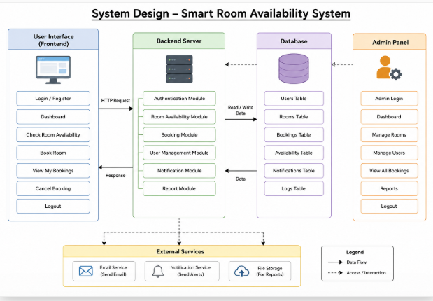

Description of System Components

Frontend Layer
The frontend provides interaction between users and the system. Users can search rooms, check availability, and make bookings.

Functions:
- User Login/Register
- Search Rooms
- Check Availability
- Booking Form
- Display Room Details

Technologies:
- HTML
- CSS
- JavaScript
- React

Backend Layer
The backend handles system processing and business logic. It receives requests from the frontend and communicates with the database.

Functions:
- Process Bookings
- Manage User Requests
- Room Availability Checking
- Authentication
- Database Connection

Technologies:
- Node.js
- Express.js

Database Layer
The database stores all room and booking information securely.

Functions:
- Store Room Details
- Store Booking Records
- Manage User Information
- Retrieve Availability Data

Technology:
- MySQL

Admin Panel
The admin panel allows administrators to manage rooms and bookings.

Admin Features:
- Add New Rooms
- Update Room Details
- Delete Rooms
- View Bookings
- Manage Users

Module Decomposition
The Room Availability System is divided into multiple modules for better organization and maintenance.

Main Modules:
- Authentication Module
- Room Management Module
- Booking Module
- Availability Module
- Admin Module
- Database Module

Functional Requirements
Functional requirements describe the major features of the system.

The system should:
- Allow users to register and login.
- Display available rooms.
- Allow room booking.
- Show booking confirmation.
- Allow admin to manage rooms.
- Store booking records in database.
The system should also provide real-time room availability information to users.

Non-Functional Requirements
Non-functional requirements describe system quality and performance.

Important Requirements:
- Fast response time
- Secure data storage
- User-friendly interface
- Reliable booking system
- Accurate room availability status
The system should maintain smooth communication between frontend and backend components.
Advantages of the Proposed System

Benefits:
- Reduces manual work
- Saves time
- Easy room management
- Accurate booking records
- Fast availability checking
- Better user experience

Conclusion
The High-Level Design of the Room Availability System provides a clear overview of system architecture and module decomposition. The system is designed to provide efficient room management, secure booking operations, and an easy-to-use interface for both users and administrators.

Low-Level Design (LLD)

Introduction
Low-Level Design (LLD) explains how the Room Availability System works internally. It shows the step-by-step process of room booking, user actions, and database operations. This design helps developers understand system working in a simple way.
The system allows users to check available rooms, book rooms, and save booking information in the database.

Flowchart Diagram
The flowchart shows the complete process of room booking from login to booking confirmation.

Main Steps:
- User opens system
- User logs in
- User searches rooms
- System checks availability
- User books room
- Booking data is saved
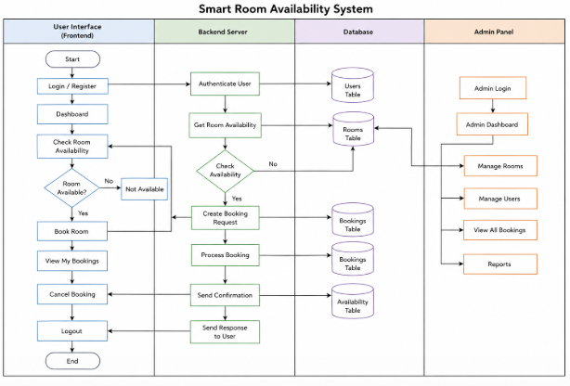

Explanation
First, the user opens the system and logs in. After login, the user searches for rooms. The system checks if rooms are available or not. If available, the user books the room and the booking information is saved.

Class Diagram
The class diagram shows the main classes used in the system and their functions.

Main Classes:
- User
- Room
- Booking
- Admin
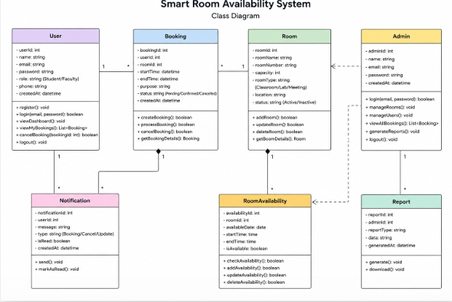

Explanation
The User class handles login and registration. The Room class stores room details. The Booking class manages booking information, while the Admin class manages rooms and bookings.
Sequence Diagram
The sequence diagram shows communication between user, system, and database during room booking.
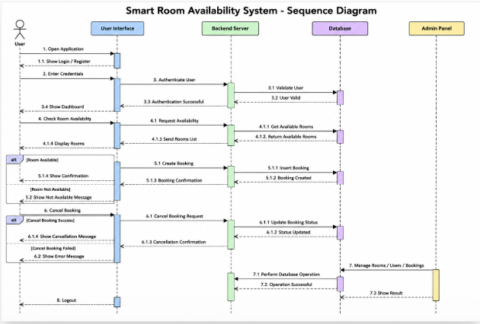

Booking Process:
- User searches room.
- System checks database.
- Database returns result.
- Booking is confirmed.
- User gets confirmation.
User -> System : Search Room
System -> Database : Check Room
Database -> System : Room Status
System -> Database : Save Booking
System -> User : Booking Confirmed

Explanation
The user searches for a room. The system checks room status from the database. If the room is available, the booking is saved and confirmation is shown to the user.

ERD Diagram
The ERD diagram shows database tables and relationships
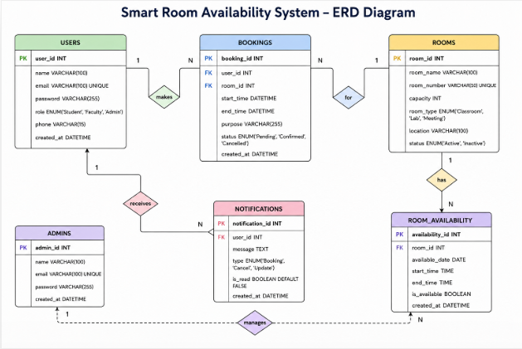.

Main Tables:
- Users
- Rooms
- Bookings

Explanation
One user can make many bookings. Each booking is connected to one room. The Rooms table stores room information and availability status.

Advantages of the System

Benefits:
- Easy room booking
- Fast room checking
- Saves time
- Easy data management
- Secure booking records
- User-friendly system

Conclusion
The Low-Level Design explains the detailed working of the Room Availability System. It includes flowchart, class diagram, sequence diagram, and ERD diagram. The design helps in understanding system flow, booking process, and database relationships in a simple way.

Implementation (Lightweight)

Introduction
In this phase, a simple working prototype of the Room Availability System is developed. The prototype allows users to check available rooms and book rooms. The system uses a frontend interface, backend processing, and database connection.
The purpose of this phase is to show the basic working model of the project.

Prototype Overview
The Room Availability System prototype helps users:
- View available rooms
- Check room status
- Book rooms
- Save booking information
The admin can manage room details and availability status.

Technologies Used

Frontend:
- Streamlit
- HTML
- CSS

Backend:
- Python

Database:
- MySQL Workbench

System Modules Implemented

Login Module
The login module allows users to enter username and password to access the system.

Features:
- User login
- Basic authentication
- Dashboard access

Room Availability Module
This module shows available and unavailable rooms.

Features:
- Display room list
- Show room status
- Search available rooms

Booking Module
The booking module allows users to reserve rooms.

Features:
- Select room
- Enter booking details
- Confirm booking
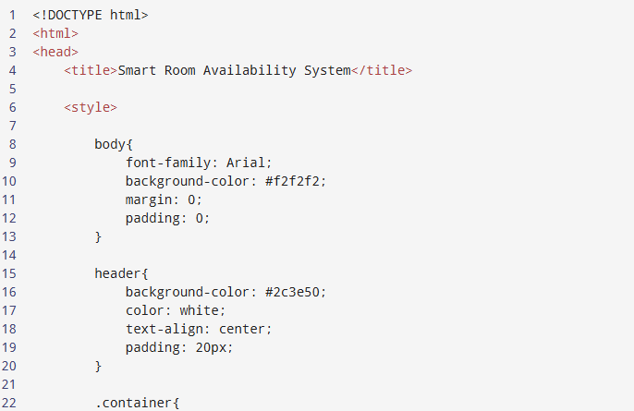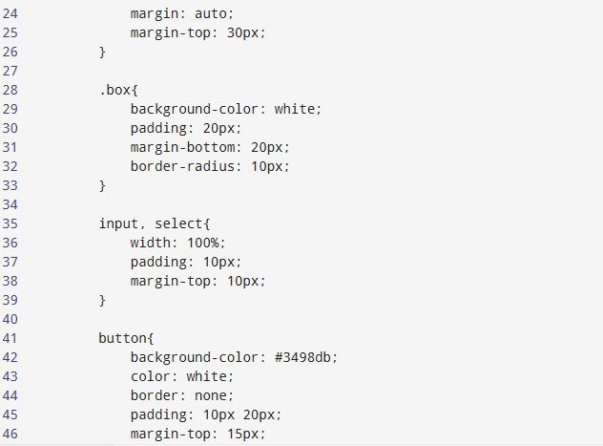
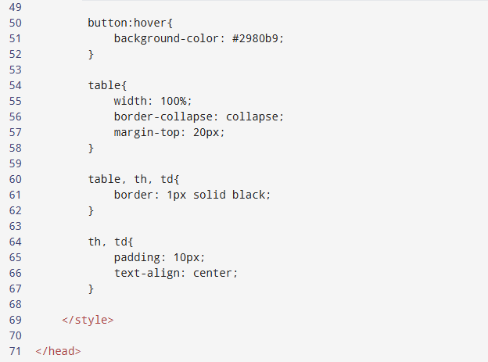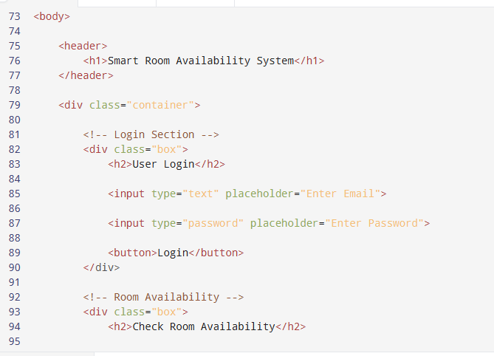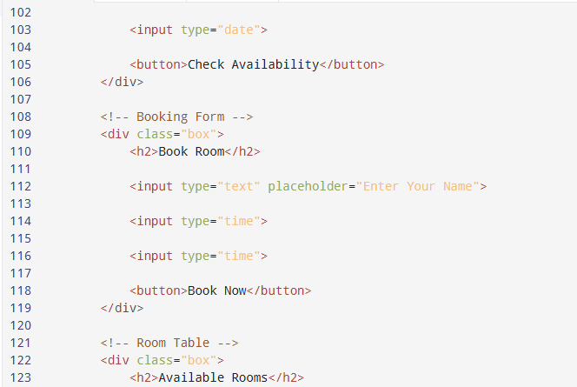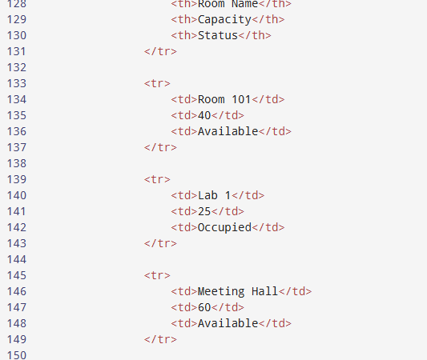
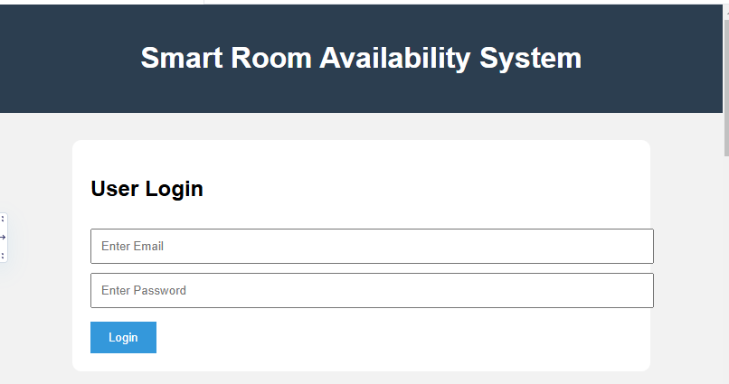

Database Module
The database stores room and booking information.

Stored Data:
- User details
- Room details
- Booking records

Frontend Design
The frontend interface is simple and user-friendly. Users can:
- Login to system
- View rooms
- Check room status
- Book rooms easily
The interface is created using Streamlit and basic HTML/CSS.

Database Implementation
The system database contains the following tables:

Tables:
- Users
- Rooms
- Bookings
The database is connected using MySQL.

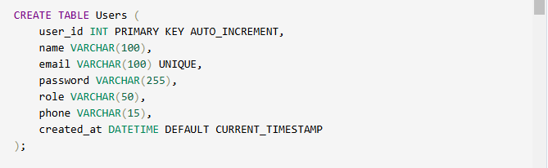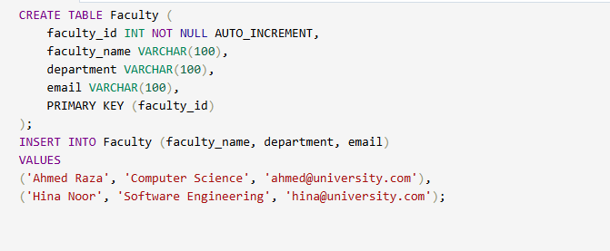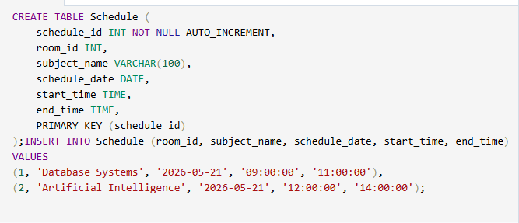

Basic Prototype Features

Implemented Features:
- User Login
- Room Availability Checking
- Room Booking
- Booking Confirmation
- Database Storage

Advantages of Prototype

Benefits:
- Easy room management
- Fast room checking
- Saves booking records
- User-friendly system
- Simple implementation

Conclusion
The implementation phase provides a basic working prototype of the Room Availability System. The prototype successfully performs room checking and booking operations. It also stores booking data in the database and provides a simple interface for users.

